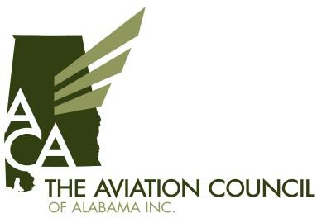

Joint-Membership Application

The purpose of The Aviation Council of Alabama, a non-profit corporation, and its partnership with the General Aviation Alliance of Alabama is to foster and promote aviation facilities, safety, business, and aerospace public policy in Alabama. The Aviation Council of Alabama and General Aviation Alliance of Alabama’s mission are to bring together the various interests and talents of individual, bureau, corporations, companies, agencies, departments, professionals and municipalities, for stated purpose. Those interested in promoting the cause of aviation in Alabama shall be eligible for membership upon making application and paying the prescribed membership fee. This application shall qualify as a joint membership with the General Aviation Alliance of Alabama and the Aviation Council of Alabama.

Airport / Company Name

Address City / State Zip

Contact Person Title

Telephone # Email

- Commercial Service Airports
Non-Hub $1,750
Small-Hub $2,750

- General Aviation Airports (NPIAS Categories)
Unclassified $0
Basic $0
Local $100
Regional $750
National $1000

- Partner
FBO / On-Airport $250
Corporate Member/Consultant $500
Military/Government $0

- Individual $100

- Student (Non-Voting) $25

- Membership Options:
ACA Foundation Scholarship Fund $________
Prime Partner (Website Recognition) $500

Total Amount of Dues:

Thank you for supporting The Aviation Council of Alabama, Inc.
Please return a copy of this form with your check. Mail to: The Aviation Council of Alabama, Inc.

P.O. Box 1398
Wetumpka, AL 36092

